Building into the Future: Habitat Minnesota’s Strategic Plan

In a time of great uncertainty and change, Habitat for Humanity of Minnesota sought to plan the unplannable and took on a deep and thorough strategic planning process. The effort involved staff, board, and leaders of the Minnesota, South Dakota, and North Dakota Habitat affiliates which Habitat Minnesota serves.

“We spoke to all the affiliates and learned how unique each affiliate is. They all have different strengths, needs, priorities, challenges and styles. We worked really hard to balance everything in the plan,” said Bret Busse, board vice-chair and leader of the strategic planning committee.

Habitat Minnesota was created in 1997 by the Minnesota Habitat affiliates, initially as a financial intermediary, providing centralized distribution of capital to affiliates. Today, Habitat Minnesota offers a range of programs, including resource development, advocacy, training, and networking. Over the last 24 years, Habitat Minnesota has evolved its programs and services to meet the ever-changing needs of the Minnesota affiliates and to improve affordable homeownership in the state of Minnesota.

“Habitat Minnesota was founded and created to support the work of Habitat affiliates in our state and to increase affordable homeownership opportunities statewide. I’m excited for a strategic plan that was created in this foundational approach to our work and I look forward to seeing an increase in production statewide,” said President and CEO Cristen Incitti.

In January 2020, newly hired Cristen Incitti convened the Habitat Minnesota board of directors to begin the strategic planning process. A strategic planning committee was created, made up of six board members. New board members, along with interim staff member Dawn Hill, interviewed 19 Minnesota affiliates, as well as four in South Dakota, two in North Dakota, and two in Wisconsin, to obtain a full and regional picture of Habitat affiliate needs.

This process allowed new board members and affiliate leaders to get to know one another. It also gave board members a greater understanding of the unique challenges each affiliate faces based on staff size, geographic area, and many other factors.

Kevin Pelkey, Lakes Area Habitat Executive Director and a member of Habitat Minnesota’s board and strategic planning committee, was pleased with the comprehensive affiliate interview process. Said Pelkey, it’s “important to take time—every year—to engage [the Habitat Minnesota] board in learning just how affiliates operate and just how different every affiliate is.”

Along with the plan, Habitat Minnesota revised its mission and vision and created organizational values and a guiding philosophy.

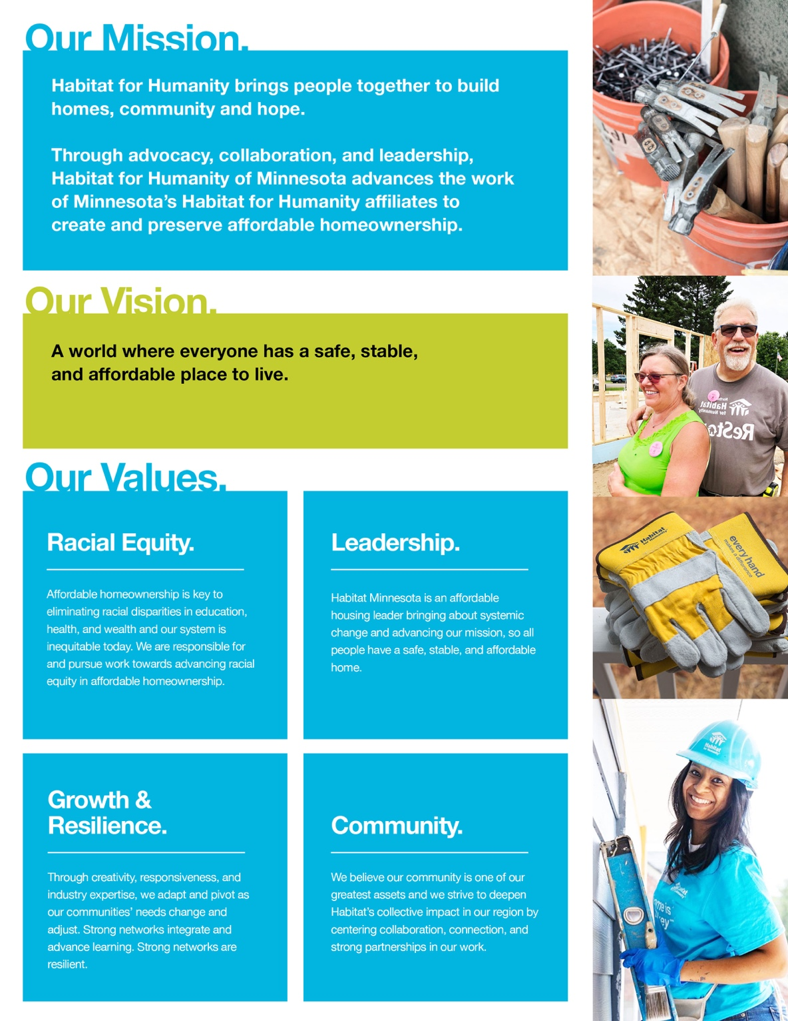
Guiding Philosophy: Founded in Christian principles, centered in a radical effort to create and live out a vision for our world where everyone has a safe, stable and affordable place to live, Habitat Minnesota is committed to an intersectional approach to diversity, equity, inclusion and anti-racism. ​

We are on a journey with an intentional pursuit of equity in housing to create a world where there is no housing discrimination in our communities.​

All people have a right to a safe, stable and affordable place to live, and we are working towards dismantling the systemic barriers to this goal for communities who have been historically marginalized and intentionally left behind.

Habitat Minnesota is an affordable homeownership leader bringing about systemic change and advancing our mission, so all people have a safe, stable, and affordable home.

Said Julie Gugin, Habitat Minnesota board chair and member of the strategic planning committee, “I’m excited that Habitat for Humanity of Minnesota is being bold and intentional about its values. Racial equity as a driving principle is critical.”

Our new strategic plan is a four-year plan for FY2022 (July of 2021)—FY2025. The plan covers four strategic priorities.
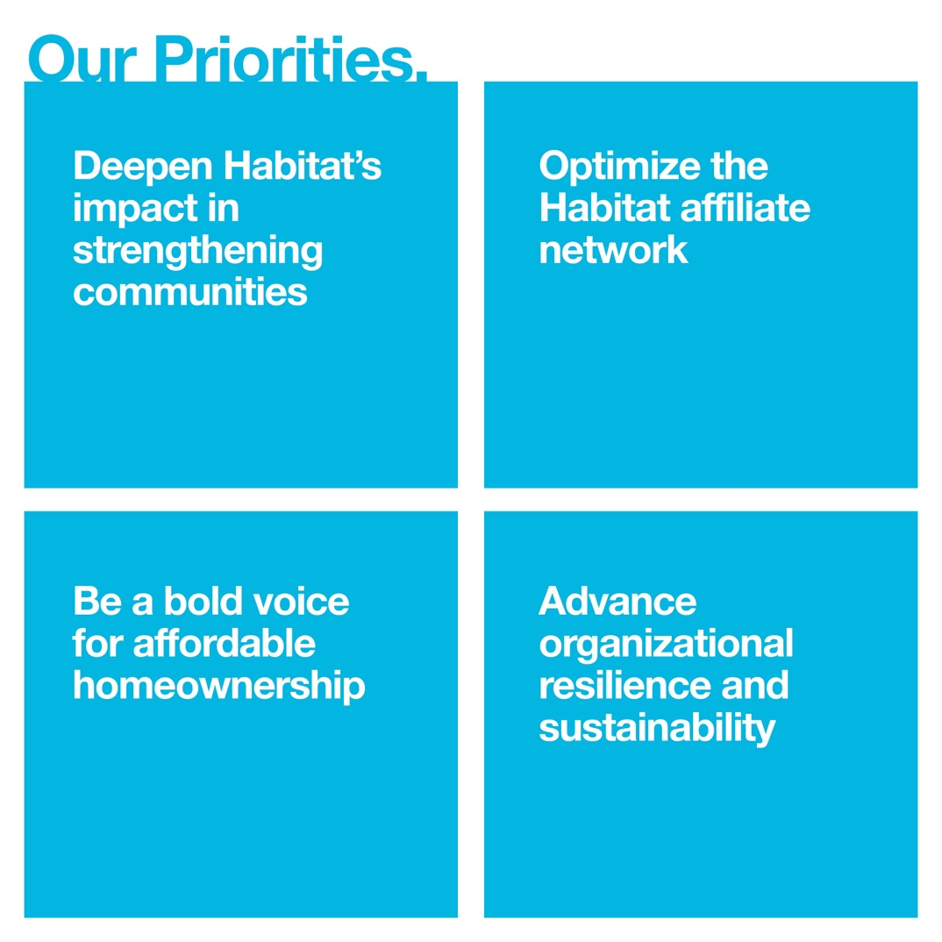
This plan will help the staff and board at Habitat Minnesota to focus and prioritize our programs and services over the next four years: begin new initiatives, strengthen and grow existing programs, and end or revise programs that aren’t moving us forward. We’ll be reporting out how we’re tracking on each strategic priority over the next four years and connecting those strategies to many parts of our work: hiring, partnerships, program delivery, and fundraising.

“Our work is deeply connected to strong partnerships and collaboration – we cannot succeed in the pursuit of our mission without a strong network of partners. This plan centers partnerships with Habitat affiliates, communities, BIPOC-led organizations, and many others to advance the goal of closing the racial gap in ownership and creating more wealth building opportunities through ownership statewide. Habitat Minnesota has outlined actionable ways to partner with others to tackle the affordable ownership challenges we have as a state and I’m excited for us to get to work,” said Incitti.

“We’re focused on giving affiliates the tools and resources they need to thrive,” said Busse. “The strategic plan provides a framework and guidelines for what this looks like now, but it will continue to evolve and iterate as we go, so it might look a bit different each year. I’m excited about where we’re headed.”

